Kickstarter Challenge Written Analysis

# Overview of Project

Louise is raising funds for her play. This report is intended to provide an analysis of how the launch date and funding goals affect the rate of success of a funding project. The analysis is based on the information and result of 4,114 different projects, including funding goals, pledged amount of funding, country, launch date, etc. The report will also provide visualization to assist in understanding the result.

# Analysis and Challenges

Analysis of Theater Outcomes by Launch Date

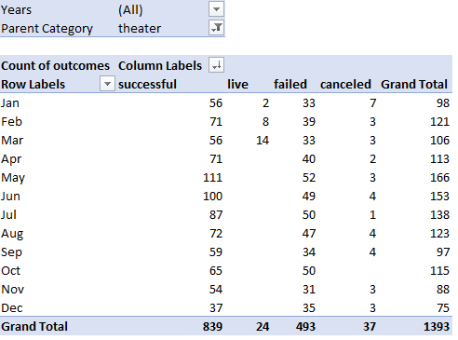 The analysis of theater outcomes by launch date is conducted by using the pivot table function in excel to create an overview table of the number of successful, live, failed, and canceled fundraising projects in each month. A line chart is then created to visualize the frequency of each outcome in each month of the year. The line chart provides a clearer picture of which month has the highest frequency of success, failure, and cancellation.

Figure Pivot table of theater outcomes by launch date

Analysis of Theater Outcomes Based on Goals

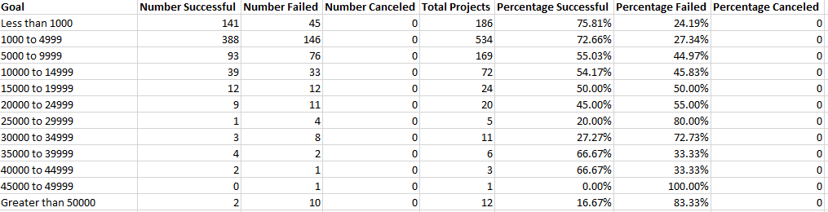To analyze the outcome based on goals, a table is created containing the range of goals, the number of successes, failure, cancelation, and the percentage of each of the categories mentioned to the total number of projects. The value of table is derived from the main “Kickstarter” worksheet. The total number of each outcome is obtained using the “COUNTIFS” function in Excel. The goal is categorized from less than 1000 to greater than 50,000, with a 5,000 interval for each of the categories in between. A line chart is created to visualize the percentage successful, percentage failed, and percentage canceled for each category of the goal.

Figure table for analysis of theater outcomes based on goals

Challenges

The challenge while conducting the analysis is to place the data properly into filters, columns, rows, and values. Another challenge that I encountered is to select the correct range for the data. For analysis of theater outcomes based on goals, the margin of error when using the “COUNTIFS” function with multiple criteria is very high, especially when there are multiple categories involved. Several mistakes were made during the table construction and it was time-consuming to pinpoint the error.

# Results

Conclusions based on Launch Date

The chart “theater outcome by launch date” shows that the highest frequency of success happens in May. However, the total number of projects in May is also the highest, so the percentage for each criteria of outcomes needs to be calculated.

The percentages indicate that projects that are launched in May has the highest percentage of success. Another conclusion which can be draw is that December has the lowest rate of success both in frequencies and percentages. December also has the highest failure rate compare to other months.

Conclusion based on goals

The conclusion based on goals indicate that projects with a goal that is greater than $50,000 has have the highest rate of failure. Project with goal less than $1,000 has the highest rate of success. In general, the lower the goal, the higher the success rate. However, it is worth to know that there are fewer projects as the goal increases, so there may not be enough sample size to draw such a conclusion.

Limitations

There are several limitations that should be addressed. First, the data is not based on randomly selected samples, and all of them are launched between 2014 and 2016. Therefore, the result cannot be exclusively applied to the general population, and there may be bias in the result due to the cyclical component. Furthermore, it is difficult to draw a conclusion on outcome based on goals since there is disproportionally more project with a funding goal that is less than $15,000. As a result, the success rate of projects with a funding goal of more than $15,000 is not accurately reflected. The currency is also not standardized. To make the analysis more accurate, there is a need for a larger sample size a standardized currency. The sample also needs to be randomly selected through a larger time span to eliminate bias.